Amaan Vahora

Student ID:- 101492067

minikube start --nodes 2 -p multinode-demo

kubectl get nodes

minikube status -p multinode-demo

minikube stop -p multinode-demo

minikube delete --all

kubectl apply -f replicaset.yaml

kubectl get pods

kubectl delete pod nginx-27dsb



kubectl get pods

kubectl get replicasets

kubectl get deployments

kubectl rollout status deployment nginx-deployment



kubectl apply -f stateful-nginx.yaml

kubectl get statefulsets

kubectl apply -f daemonSet-nginx.yaml

kubectl get daemonset

kubectl apply -f nginx-deployment-resource-limit.yaml

kubectl get deployments

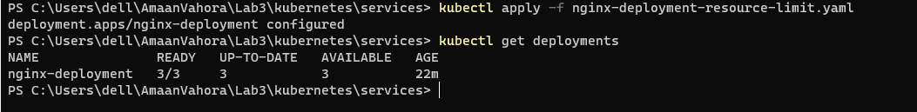

kubectl apply -f nginx-deployment-healthcheck.yaml

kubectl get deployments

